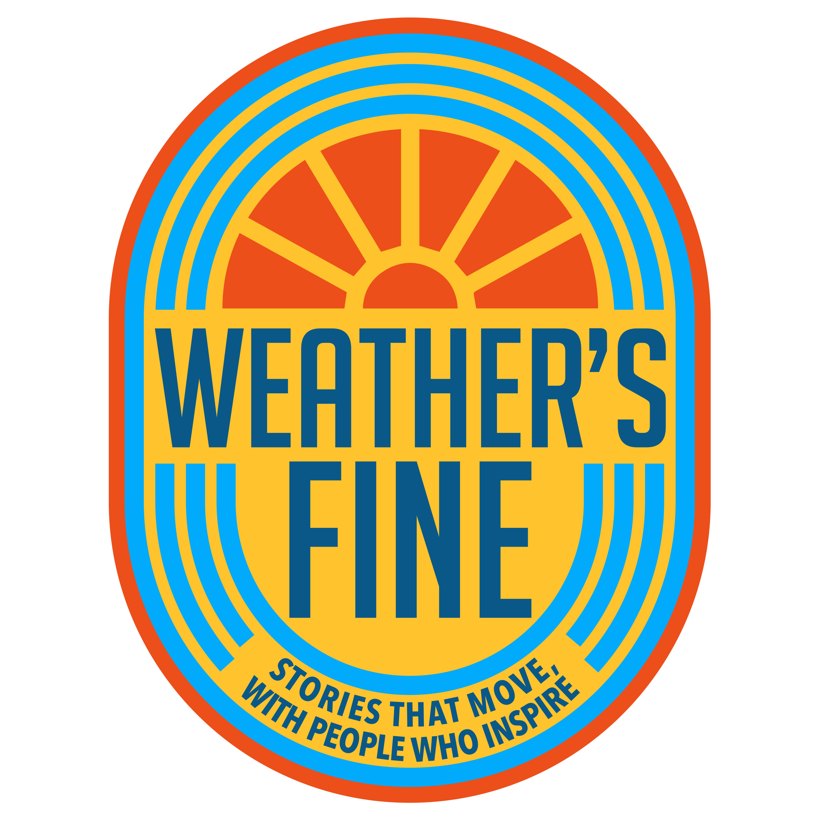

Guest Application Form

Video & Audio Interview Waiver, Release, and Consent Form
This Video & Audio Interview Waiver and Release (“Agreement”) is made between Weather’s Fine Podcast (“Producer”) and the undersigned participant (“Guest”).
Our goal at Weather’s Fine is to create a podcast that will be entertaining for the viewer. It is our intention when producing the show to shed the best possible light on our guest and their mission/passion in an effort to uplift the Guest, the crew and our viewers.
By signing below, Guest agrees to the following terms:
1. Consent to Record
I, ______________________________, voluntarily agree to participate in a recorded interview with Producer, which may include video, audio, photography, and behind-the-scenes footage captured during the mobile/run-based interview.
I understand that these recordings may include:
- My voice
- My image and likeness
- My statements, stories, and responses
- Ambient sounds or environmental audio captured during the run
2. Rights Granted
I grant Weather’s Fine Podcast, its host(s), producers, affiliates, and licensees the unrestricted right to:
- Record, use, reproduce, edit, distribute, transmit, broadcast, and publicly display the interview and all related materials
- Use my name, likeness, voice, and biographical information in connection with the podcast, promotional content, merchandise, and all media
- Create derivative works from the recorded material
- Use the content worldwide, in perpetuity, without additional approval or compensation

3. Media & Platforms Covered
I understand that my appearance may be used across any media format, including but not limited to:
- Podcast platforms (Spotify, Apple Podcasts, etc.)
- Social media (YouTube, TikTok, Instagram, Facebook, etc.)
- Websites and promotional materials
- Video clips, highlight reels, advertisements, and merchandise
- Streaming, broadcast television, or future platforms not yet known
4. No Obligation to Use
I agree that Weather’s Fine is not required to use my interview or any portion of it, and may edit or adapt the content at its discretion.
5. Release of Liability
I hereby release and discharge Weather’s Fine, its host(s), crew, affiliates, sponsors, and assigns from any and all claims, demands, or causes of action arising out of or connected with:
- The recording of my likeness or voice
- The use of the content
- The running or mobile nature of the interview environment
I confirm that I am participating voluntarily and I am physically capable of completing a moderate run. I accept full responsibility for my own health and safety.
6. Ownership
I understand that all recordings, footage, and related materials are the exclusive property of Weather’s Fine, and I waive any right to inspect or approve the final product.
7. Confidentiality
I acknowledge that I should not disclose confidential, proprietary, or sensitive information belonging to my employer or other parties. Any statements made during the run are voluntary and may be published.
8. Governing Law
This Agreement is governed by the laws of the state in which the recording occurs, unless otherwise required by law.
9. Acknowledgment
By signing, I confirm that:
- I am at least 18 years old
- I have read and understand this release
- I agree to the terms voluntarily
- I understand this agreement is legally binding

Guest Information & Signature
Name: ___________________________________________

Email: ___________________________________________

Phone: ___________________________________________

Availability Interview dates: ____________________________

Signature: ________________________________________

Date Signed: ______________________________________

SECTION 1 — PERSONAL INFORMATION

Social Media Handles (IG, TikTok, YouTube) if any:
_________________________________________________________________________________________________________

Website, If Any (optional):
_________________________________________________________________________________________________________

SECTION 2 — STORY & BACKGROUND
1. Briefly tell us who you are and what you do:
___________________________________________________________________________________________________________________________________________________________________________________________________________________________________________________________________________________________________________________________

2. What part of your life story most shaped who you are today?
___________________________________________________________________________________________________________________________________________________________________________________________________________________________________________________________________________________________________________________________

3. What is one major turning point, breakthrough, or challenge you've experienced?
___________________________________________________________________________________________________________________________________________________________________________________________________________________________________________________________________________________________________________________________

SECTION 3 — FIT FOR THE SHOW
4. Why do you believe you’d be a great fit for a running podcast?
___________________________________________________________________________________________________________________________________________________________________________________________________________________________________________________________________________________________________________________________

5. Have you done interviews or public speaking before? (Yes/No) If yes, describe:
___________________________________________________________________________________________________________________________________________________________________________________________________________________________________________________________________________________________________________________________

6. Are you comfortable running at a conversational pace for 40 minutes? (Yes / Yes w/ breaks / Not sure)
___________________________________________________________________________________________________________________________________________________________________________________________________________________________________________________________________________________________________________________________

7. What unique perspective or message would you want viewers to walk away with?
___________________________________________________________________________________________________________________________________________________________________________________________________________________________________________________________________________________________________________________________

8. What emotions are you most comfortable sharing on camera?
___________________________________________________________________________________________________________________________________________________________________________________________________________________________________________________________________________________________________________________________
9. Topics you prefer NOT to discuss:
___________________________________________________________________________________________________________________________________________________________________________________________________________________________________________________________________________________________________________________________

SECTION 4 — SOCIAL IMPACT & REACH (Optional)
10. Current audience or following size:
__________________________________________________________________________________________________________________________________________________________________________________________________________________
11. Willing to promote your episode? (Yes / Possibly / No)
____________________________________________
12. What type of content do you create, hope to create, or appear in?
___________________________________________________________________________________________________________________________________________________________________________________________________________________________________________________________________________________________________________________________

SECTION 5 — LOGISTICS
13. Would you be able to interview in the Cincinnati tri-state area, If yes, do you have a Trail or course you prefer for your interview?

14. If No, what City, State would you like us to travel to meet you and do you have a trail/course in mind?
___________________________________________________________________________________________________________________________________________________________________________________________________________________________________________________________________________________________________________________________

15. Preferred recording days (Weekdays / Weekends / Flexible):
______________________________________________________________________________________________________

16. What is one thing you’ve never talked about publicly… but might be open or would like to discuss during a run?
___________________________________________________________________________________________________________________________________________________________________________________________________________________________________________________________________________________________________________________________
17. Is there one consistent question or questions you’d like to see asked of each of our Guests, if yes please list?

__________________________________________________________________________________________________________________________________________________________________________________________________________________

SECTION 6 — FINAL QUESTION

18. Do you have a personal relationship with someone who you believe would make a great guest for the show? Please list.
___________________________________________________________________________________________________________________________________________________________________________________________________________________________________________________________________________________________________________________________

